

**ISTANBUL AYDIN UNIVERSITY**

**SOFTWARE ENGINEERING**

**2018-2019 Spring Semester**

**Lecture Name:** COMPUTER PROGRAMMING-II

**Lecture Code:** SEN114

**Assignment-I**

**Student Name:** Beytullah Gürsoy

**Student ID:** B1505.090031

**Introduction to Java Programming**

Java is a general-purpose computer **programming language** that is [concurrent](https://howtodoinjava.com/java-concurrency-tutorial/), class-based, [object-oriented](https://howtodoinjava.com/oops/object-oriented-principles/), and specifically designed to have as few implementation dependencies as possible. Java code can run on all platforms that support Java without the need for recompilation.

Java was designed with a few key principles in mind:

* **Ease of Use**
* **Reliability**
* **Security**
* **Platform Independence \*\***

The Oracle implementation is packaged into two different distributions:

1. Java Runtime Environment (JRE) which contains the parts of the Java SE platform required to run Java programs and is intended for end users.
2. Java Development Kit (JDK) which is intended for software developers and includes development tools such as the Java compiler, Javadoc, Jar, and a debugger. ***

**My Purpose**

I made a project which is about a student system.This system can store datas about students. Their specific IDs, names/surnames, grades, taken lectures, averages and total average of them. There is multiple options that you can do by entering student’s ID;

* Creating new student
* Listing all students
* Listing all students info
* Listing one student’s info
* Editing student’s infos and grades etc.
* Calculating one student’s average
* Calculating total average

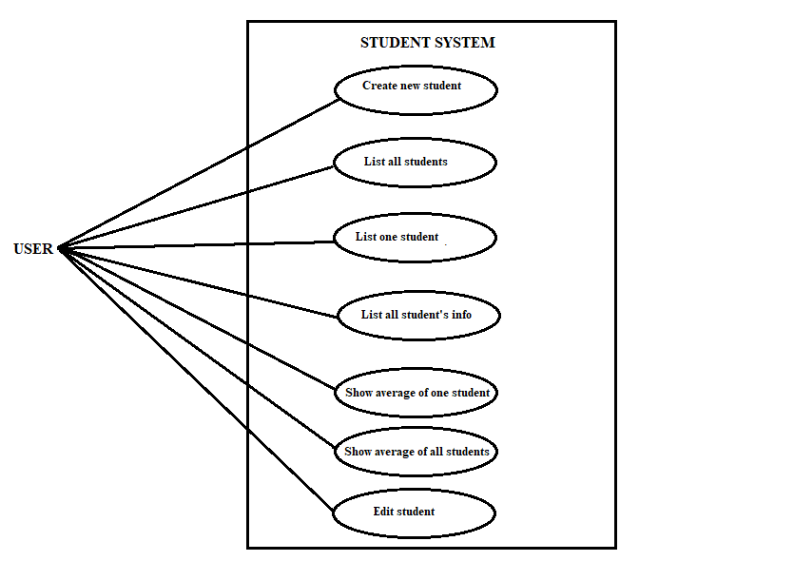**USE CASE DIAGRAM**

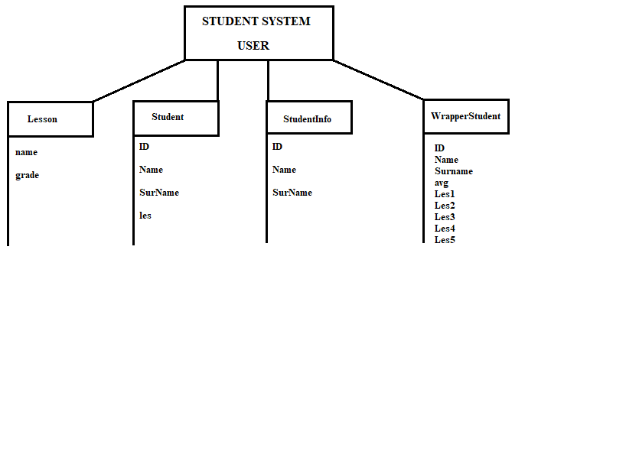**OBJECT DIAGRAM**

**CODES OF THE PROGRAM**

**INDEX PART**

import java.io.BufferedReader;

import java.io.BufferedWriter;

import java.io.FileNotFoundException;

import java.io.FileReader;

import java.io.FileWriter;

import java.io.IOException;

import java.util.ArrayList;

import java.util.Scanner;

public class Index {

public static ArrayList<WrapperStudent> wrapper=new ArrayList<WrapperStudent>();

public static void mainscreen() {

int choice = -1;

do {

Scanner input = new Scanner(System.in);

System.out.println("1- Create a new student");

System.out.println("2- List all of students");

System.out.println("3- Show student info only one student");

System.out.println("4- List all of students info");

System.out.println("5- Show average only one student");

System.out.println("6- Show average all of students");

System.out.println("7- Edit student");

System.out.println("0- Exit");

System.out.print("Choose option : ");

choice = input.nextInt();

switch(choice)

{

case 1:

createStudent();

break;

case 2:

listStudent();

break;

case 3:

showStudentInfoOneStudent();

break;

case 4:

listStudentInfo();

break;

case 5:

showAverageOneStudent();

break;

case 6:

showAverageAllof();

break;

case 7:

editStudentInfo();

break;

case 0:

System.out.println("Program closed.");

break;

default:

System.out.println("Wrong option !");

break;

}

}while(choice != 0);

}

public static void wrapStudent() {

wrapper.clear();

String line = null;

FileReader fileReader;

try {

fileReader = new FileReader("Student.txt");

BufferedReader bufferedReader =

new BufferedReader(fileReader);

while((line = bufferedReader.readLine()) != null) {

String[] l = line.split("-");

WrapperStudent ws=new WrapperStudent();

ws.ID=Integer.parseInt(l[0]);

ws.Name=l[1];

ws.Surname=l[2];

ws.Les1=Integer.parseInt(l[3]);

ws.Les2=Integer.parseInt(l[4]);

ws.Les3=Integer.parseInt(l[5]);

ws.Les4=Integer.parseInt(l[6]);

ws.Les5=Integer.parseInt(l[7]);

ws.avg=(ws.Les1+ws.Les2+ws.Les3+ws.Les4+ws.Les5)/5;

wrapper.add(ws);

}

bufferedReader.close();

} catch (IOException e) {

// TODO Auto-generated catch block

e.printStackTrace();

}

}

public static void createStudent()

{

Scanner input = new Scanner(System.in);

Student s= new Student();

System.out.print("Student ID : ");

s.ID=input.nextInt();

System.out.print("Student Name : ");

s.Name=input.next();

System.out.print("Student Surname : ");

s.SurName=input.next();

System.out.println("Added 5 lessons for this student; ");

for(int i=0; i<5;i++)

{

Lesson l = new Lesson();

System.out.print(i+1+"- Lesson Name : ");

l.setName(input.next());

System.out.print(i+1+"- Lesson Grade : ");

l.setGrade(input.nextInt());

s.les.add(l);

}

FileWriter fileWriter;

try {

fileWriter = new FileWriter("Student.txt",true);

BufferedWriter bufferedWriter = new BufferedWriter(fileWriter);

String grade="";

for(int i=0;i<5;i++)

{

grade+="-"+s.les.get(i).getGrade();

}

bufferedWriter.write(s.ID+"-"+s.Name+"-"+s.SurName+grade);

bufferedWriter.newLine();

bufferedWriter.close();

} catch (IOException e) {

// TODO Auto-generated catch block

e.printStackTrace();

}

wrapStudent();

}

public static void listStudent()

{

for(int i=0;i<wrapper.size();i++)

{

System.out.println("ID:"+wrapper.get(i).ID+" Name:"+wrapper.get(i).Name+" Surname:"+wrapper.get(i).Surname+" Lesson1:" +wrapper.get(i).Les1+" Lesson2:"+wrapper.get(i).Les2+" Lesson3:"+wrapper.get(i).Les3+" Lesson4:"+wrapper.get(i).Les4+" Lesson5:"+wrapper.get(i).Les5+" Avg:"+wrapper.get(i).avg);

}

}

public static void listStudentInfo() {

for(int i=0;i<wrapper.size();i++)

{

System.out.println("ID:"+wrapper.get(i).ID+" Name:"+wrapper.get(i).Name+"Surname:"+wrapper.get(i).Surname);

}

}

public static void showAverageAllof() {

int avg=0;

for(int i=0;i<wrapper.size();i++)

{

avg+=wrapper.get(i).avg;

}

avg=avg/wrapper.size();

System.out.println(wrapper.size()+". students average = "+avg);

}

public static void showAverageOneStudent() {

boolean check=false;

int id=-1;

Scanner input = new Scanner(System.in);

System.out.print("Enter student id : ");

id=input.nextInt();

for(int i=0;i<wrapper.size();i++) {

if(wrapper.get(i).ID==id)

{

System.out.println(wrapper.get(i).ID+" "+wrapper.get(i).Name+" "+wrapper.get(i).Surname+" AVG: "+wrapper.get(i).avg);

check=true;

break;

}

}

if(!check)

{

System.out.println("There is not student that ID.");

}

}

public static void showStudentInfoOneStudent() {

boolean check=false;

int id=-1;

Scanner input = new Scanner(System.in);

System.out.print("Enter student id : ");

id=input.nextInt();

for(int i=0;i<wrapper.size();i++) {

if(wrapper.get(i).ID==id)

{

System.out.println(wrapper.get(i).ID+" "+wrapper.get(i).Name+""+wrapper.get(i).Surname);

check=true;

break;

}

}

if(!check)

{

System.out.println("There is not student that ID.");

}

}

public static void editStudentInfo() {

boolean check=false;

int id=-1, location=-1;

Scanner input = new Scanner(System.in);

System.out.print("Enter student id : ");

id=input.nextInt();

for(int i=0;i<wrapper.size();i++) {

if(wrapper.get(i).ID==id)

{

location=i;

check=true;

break;

}

}

if(!check)

{

System.out.println("There is not student that ID.");

}

else

{

boolean q=true;

do{

int chose=-1;

System.out.println("1- Edit ID");

System.out.println("2- Edit Name");

System.out.println("3- Edit Surname");

System.out.println("4- Edit Lesson 1 grade");

System.out.println("5- Edit Lesson 2 grade");

System.out.println("6- Edit Lesson 3 grade");

System.out.println("7- Edit Lesson 4 grade");

System.out.println("8- Edit Lesson 5 grade");

System.out.println("9- Delete student");

System.out.println("0- Back to menu");

System.out.print("Choose option : ");

chose=input.nextInt();

switch(chose)

{

case 1:

System.out.print("Enter new ID : ");

wrapper.get(location).ID=input.nextInt();

reWriteTXT();

wrapStudent();

break;

case 2:

System.out.print("Enter new name : ");

wrapper.get(location).Name=input.next();

reWriteTXT();

wrapStudent();

break;

case 3:

System.out.print("Enter new surname : ");

wrapper.get(location).Surname=input.next();

reWriteTXT();

wrapStudent();

break;

case 4:

System.out.print("Enter new Lesson 1 grade : ");

wrapper.get(location).Les1=input.nextInt();

reWriteTXT();

wrapStudent();

break;

case 5:

System.out.print("Enter new Lesson 2 grade : ");

wrapper.get(location).Les2=input.nextInt();

reWriteTXT();

wrapStudent();

break;

case 6:

System.out.print("Enter new Lesson 3 grade : ");

wrapper.get(location).Les3=input.nextInt();

reWriteTXT();

wrapStudent();

break;

case 7:

System.out.print("Enter new Lesson 4 grade : ");

wrapper.get(location).Les4=input.nextInt();

reWriteTXT();

wrapStudent();

break;

case 8:

System.out.print("Enter new Lesson 5 grade : ");

wrapper.get(location).Les5=input.nextInt();

reWriteTXT();

wrapStudent();

break;

case 9:

System.out.print("Do you want to delete this student [y/n] : ");

if(input.next().equals("y") || input.next().equals("Y"))

{

wrapper.remove(location);

reWriteTXT();

wrapStudent();

q=false;

}

break;

case 0:

q=false;

break;

default:

System.out.println("Wrong option !");

break;

}

}while(q);

}

}

public static void reWriteTXT(){

FileWriter fileWriter;

try {

fileWriter = new FileWriter("Student.txt",false);

BufferedWriter bufferedWriter = new BufferedWriter(fileWriter);

for(int i=0;i<wrapper.size();i++)

{

bufferedWriter.write(wrapper.get(i).ID+"-"+wrapper.get(i).Name+""+wrapper.get(i).Surname+"-"+wrapper.get(i).Les1+"-"+wrapper.get(i).Les2+"-"+wrapper.get(i).Les3+"-"+wrapper.get(i).Les4+"-"+wrapper.get(i).Les5);

bufferedWriter.newLine();

}

bufferedWriter.close();

} catch (IOException e) {

// TODO Auto-generated catch block

e.printStackTrace();

}

}

public static void main(String[] args) {

wrapStudent();

mainscreen();

}

}

**LESSON PART**

public class Lesson {

private String name;

private int grade;

public Lesson() { }

public void setName(String n)

{

this.name=n;

}

public void setGrade(int g)

{

this.grade=g;

}

public String getName()

{

return this.name;

}

public int getGrade()

{

return this.grade;

}

}

**STUDENT PART**

import java.util.ArrayList;

public class Student extends StudentInfo{

ArrayList<Lesson> les = new ArrayList<Lesson>();

}

**STUDENTINFO PART**

public abstract class StudentInfo {

protected int ID;

protected String Name;

protected String SurName;

}

**WRAPPERSTUDENT PART**

public class WrapperStudent {

public int ID;

public String Name;

public String Surname;

public int Les1,Les2,Les3,Les4,Les5;

public int avg;

}

**PROGRAM**

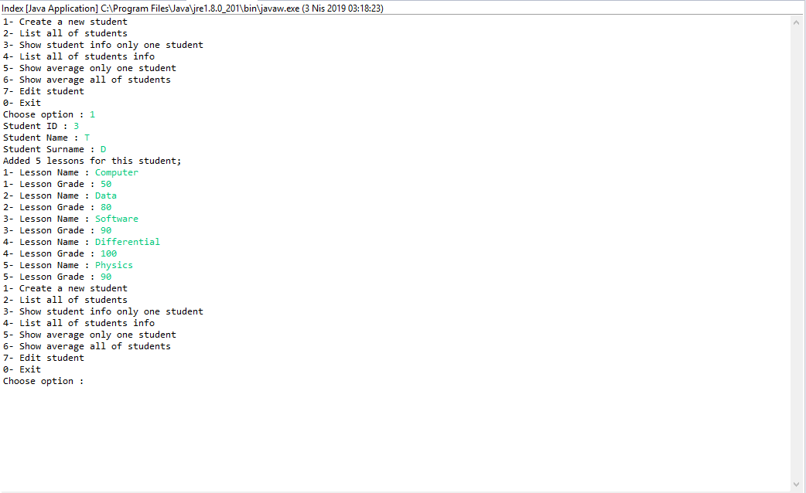**Option 1**

**Option 2**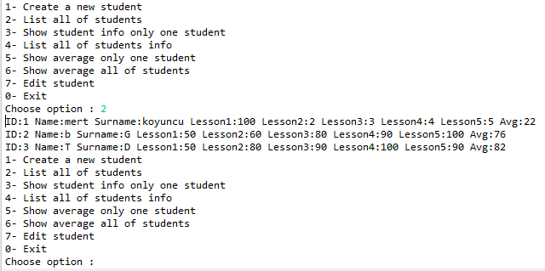

**Option 3**

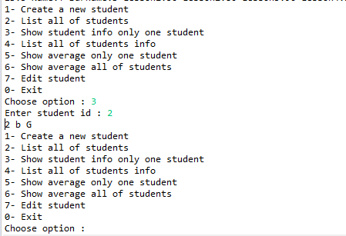

**Option 4**

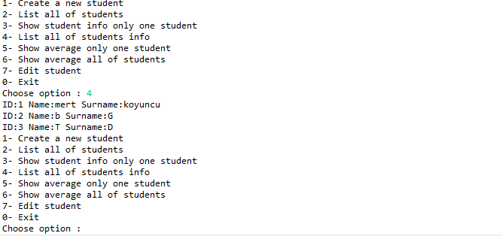

**Option 5-6**

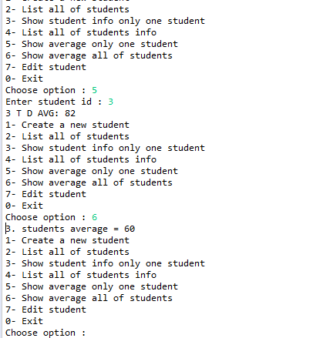

**Option 7**

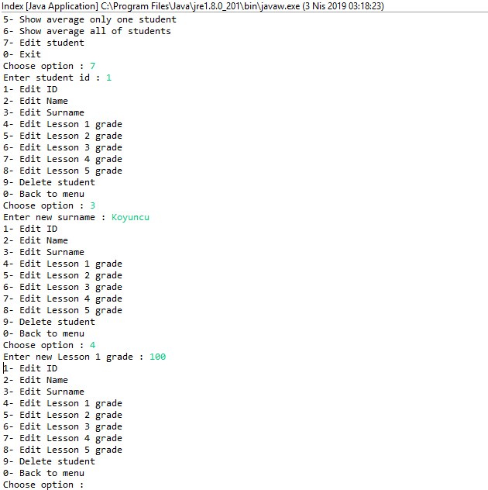

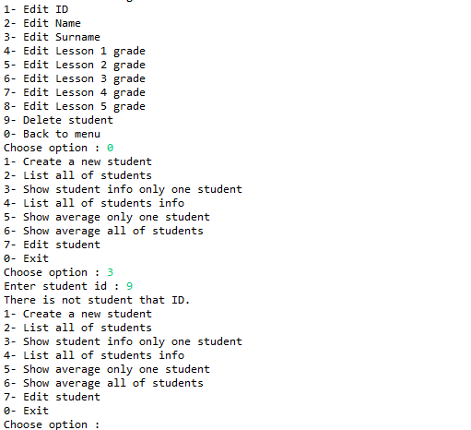

**Trying to enter wrong/not exist info**

**REFERENCES**

**Ref <https://howtodoinjava.com/>

***Ref <https://www.thoughtco.com/>